1. Write a Program to find the reverse of the String using StringBuilder
   1. Java
   2. Malayalam

public class Stringbufferreverse

{

public static void main(String args[])

{

StringBuffer sb = new StringBuffer("Java");

System.out.println("String buffer = " + sb);

sb.reverse();

System.out.println("String buffer after reversing = " + sb);

StringBuffer sb1 = new StringBuffer("Malayalam");

System.out.println("String buffer = " + sb1);

sb.reverse();

System.out.println("String buffer after reversing = " + sb1);

}

}

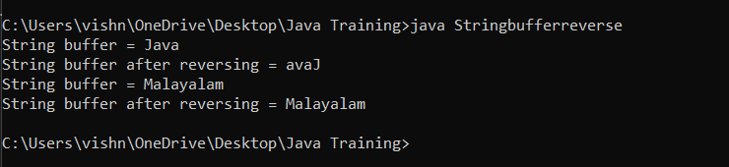

1. Write a Program to find the substring of
   1. Hello World (Output must be Hello)
   2. Hello World(Output must be World)

public class Substring

{

public static void main(String args[]){

String s="Hello World";

System.out.println("Original String: " +s);

System.out.println("Substring 1: " +s.substring(0,5));

System.out.println("Substring 2: "+s.substring(5));

}

}

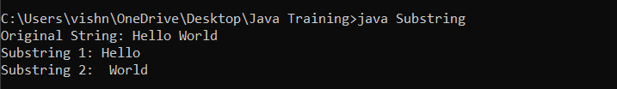

1. Program to find the reverse of a number
   1. Two constructors, one for calculation reverse and the other for display “Finding reverse…”
   2. Argument variable and instance variable should be the same (use this here)

import java.util.Scanner;

public class PaliondromeThis

{

int r;

int rev;

int temp;

int Find(int a)

{

this.temp=a;

this.r=r;

this.rev=0;

while(temp!=0)

{

r=temp%10;

rev=rev\*10+r;

temp=temp/10;

}

return Check(rev,a);

}

int Check(int rev, int a)

{

if(rev==a)

{

System.out.println("Given number is a paliondrome");

}

else

{

System.out.println("Given number is not a paliondrome");

}

return a;

}

public static void main (String args[])

{

Scanner sc = new Scanner(System.in);

System.out.println("Enter the number");

int a = sc.nextInt();

PaliondromeInstance P=new PaliondromeInstance();

P.Find(a);

}

}

